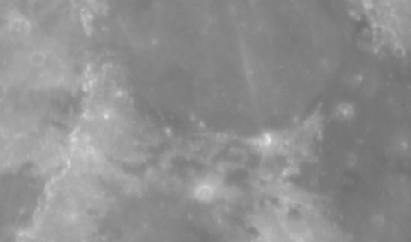

Figure 1- Mare Serenitatis (top middle) and Mare Tranquillitatis (right) in R-Band

Combining this photo in RGB with Red representing I-band, Green representing R-band and Blue representing B-band yields the following result:

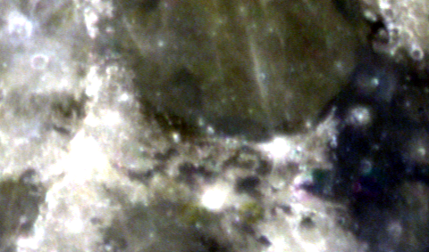

Comparing this to NASAs spectral composition of the moon shows a similar result where Mare Serenitatis is in the green-yellow part of the spectrum and Mare Tranquillitatis is in the blue-purple part.

